COSC 363 – Assignment 1

# Zachary Sanson

### 58520526

**Summary:**My graphics project “main.cpp” is a graphically generated scene of a castle in a city guarded by cannons and robots. The robots move in their own patrol guarding the entrance (holding a torch) and there is a spaceship in the centre that you have to leave from. The castle contains a stack of differently textures crates. There is lighting and shading on most objects in the scene.

**Note:**Although the brief requires an animated spaceship, my design of a basic rocket would not suffice animations while landed (unless objects like radar dishes were implemented) so I have instead created an animation for the ship to rotate.

**Hotkeys:**You can move around the scene using the arrow (**↑ ↓ ← →**)keys.  
If you hold **Shift + ↑/↓** you will change your view height.  
Pressing **Ctrl** will change your camera perspective between first person and the spaceship view.  
If you press **Z** the cannons will fire their cannon balls and if you press **X** the spaceship will launch to the sky.

**Implemented Features:**  
Textured objects – Five of them: skybox, three crates and the walls.  
Shadows – There are shadows on most important objects which interacts with the light source.  
Spotlights on moving objects – The patrolling robots hold torches which project spotlights.  
Two camera angles – One in first person and the other in third person (of the spaceship).  
Physics models – Done on the cannonball when fired, fires in an arc.  
Surfaces generated by mathematics – The archway is made from taking half a circle out of a square.

float curve_angle = (i * PI) / slices;  
float next_angle = ((i + 1) * PI) / slices;  
glVertex3f(cos(curve_angle), sin(curve_angle), j);

Collision detection – Implemented on the edges of the scene, around the skybox so you cannot move past the scene. Also implemented minimum camera height (height of human).

**Extra Features:**When you are in the spaceship view you cannot change the first person view position/direction whilst pressing the arrow keys. (Done so by implementing an if statement for the flying spaceship.)

**TODO:**Create a ‘space’ skybox for when the ship launches.  
Implement animations inside castle.  
Implement and animate some castle doors.  
Change separate ‘shadow’ functions to be done by a global parameter instead of multiple functions.

**Current Bugs:**  
Texture is stretched on the wall, possibly change texture or find a way to repeat texture after certain length.

**Examples:**

View of the castle  
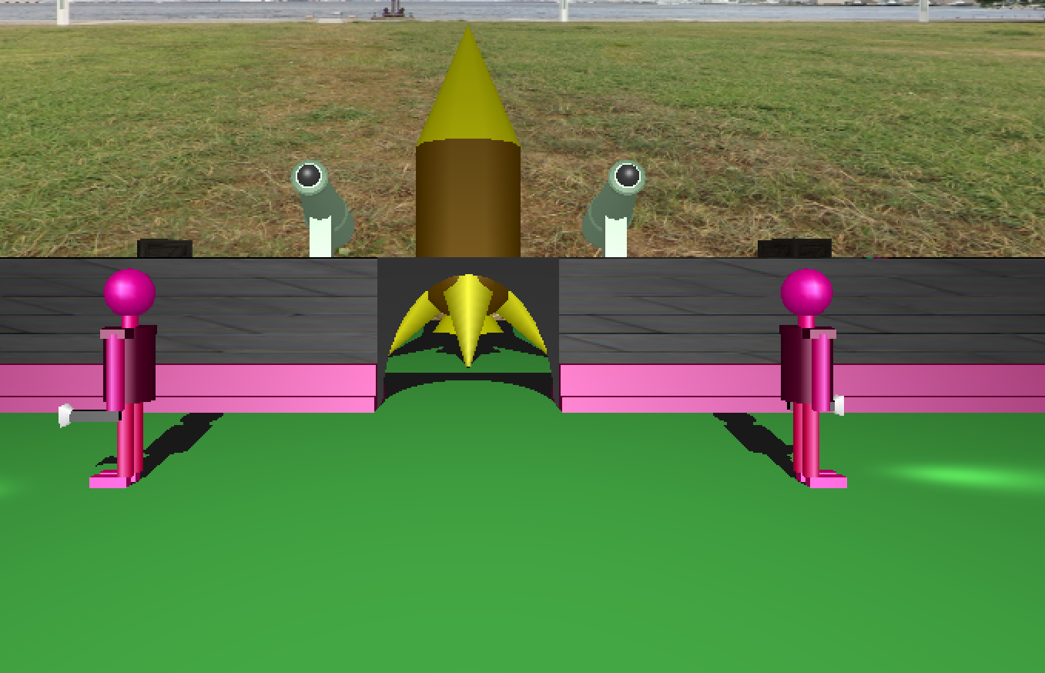

Example of firing the cannons.  
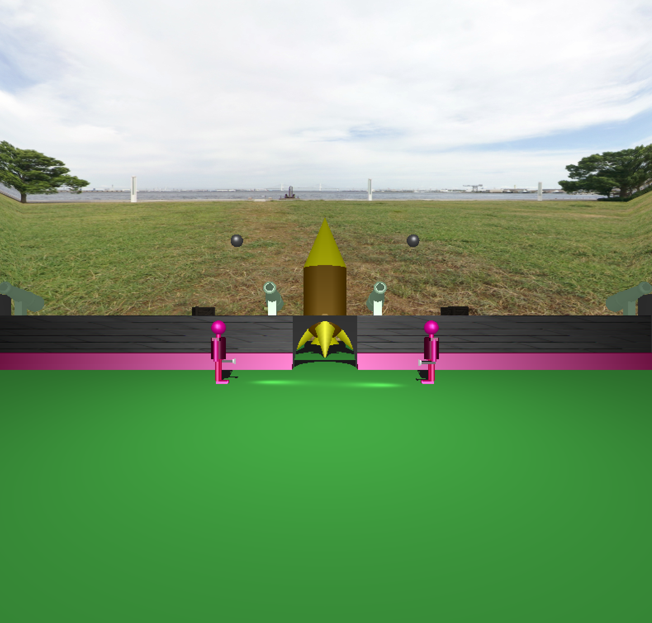

Close up of the patrolling robots  
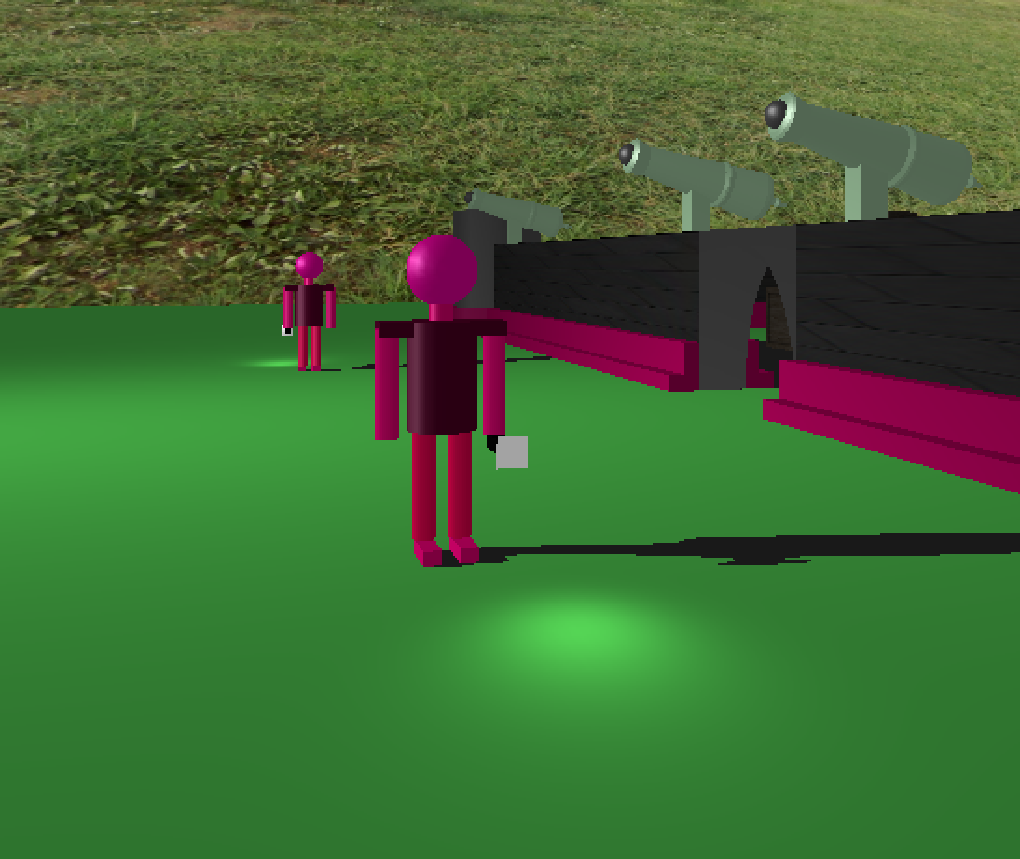

Box textures  
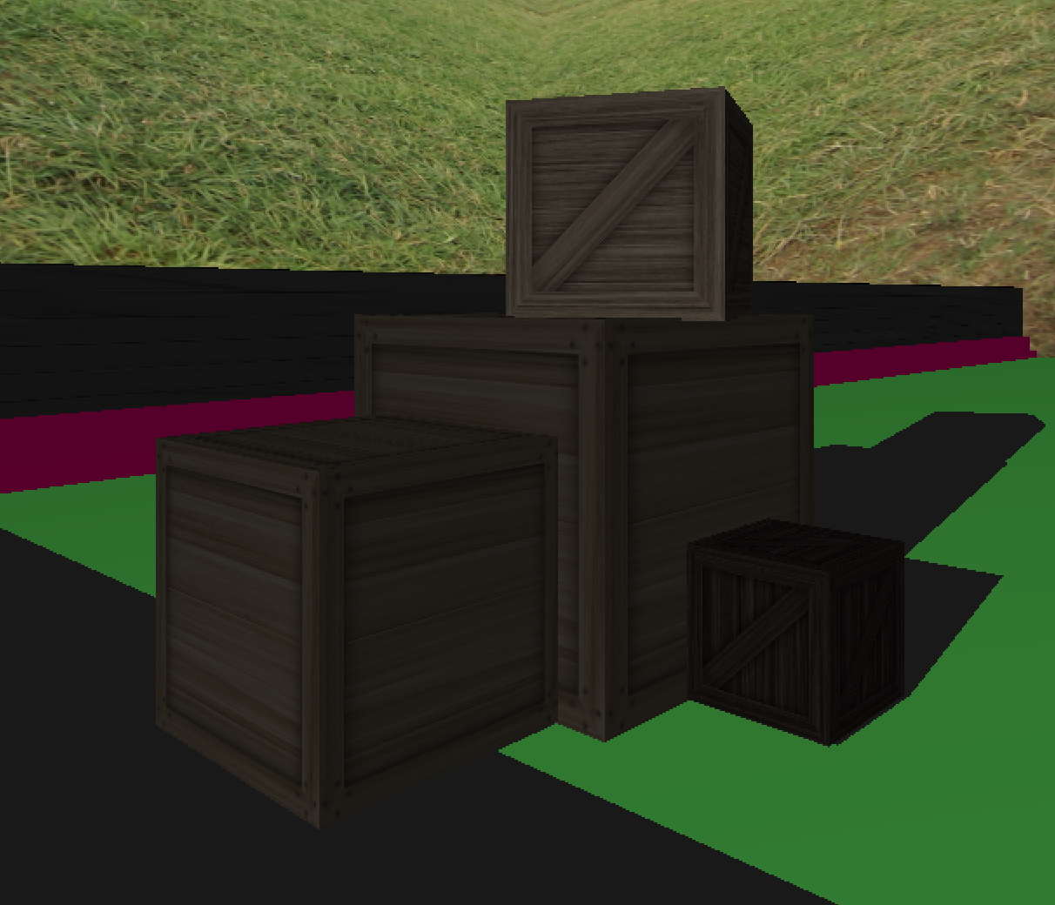

Close up of spaceship  
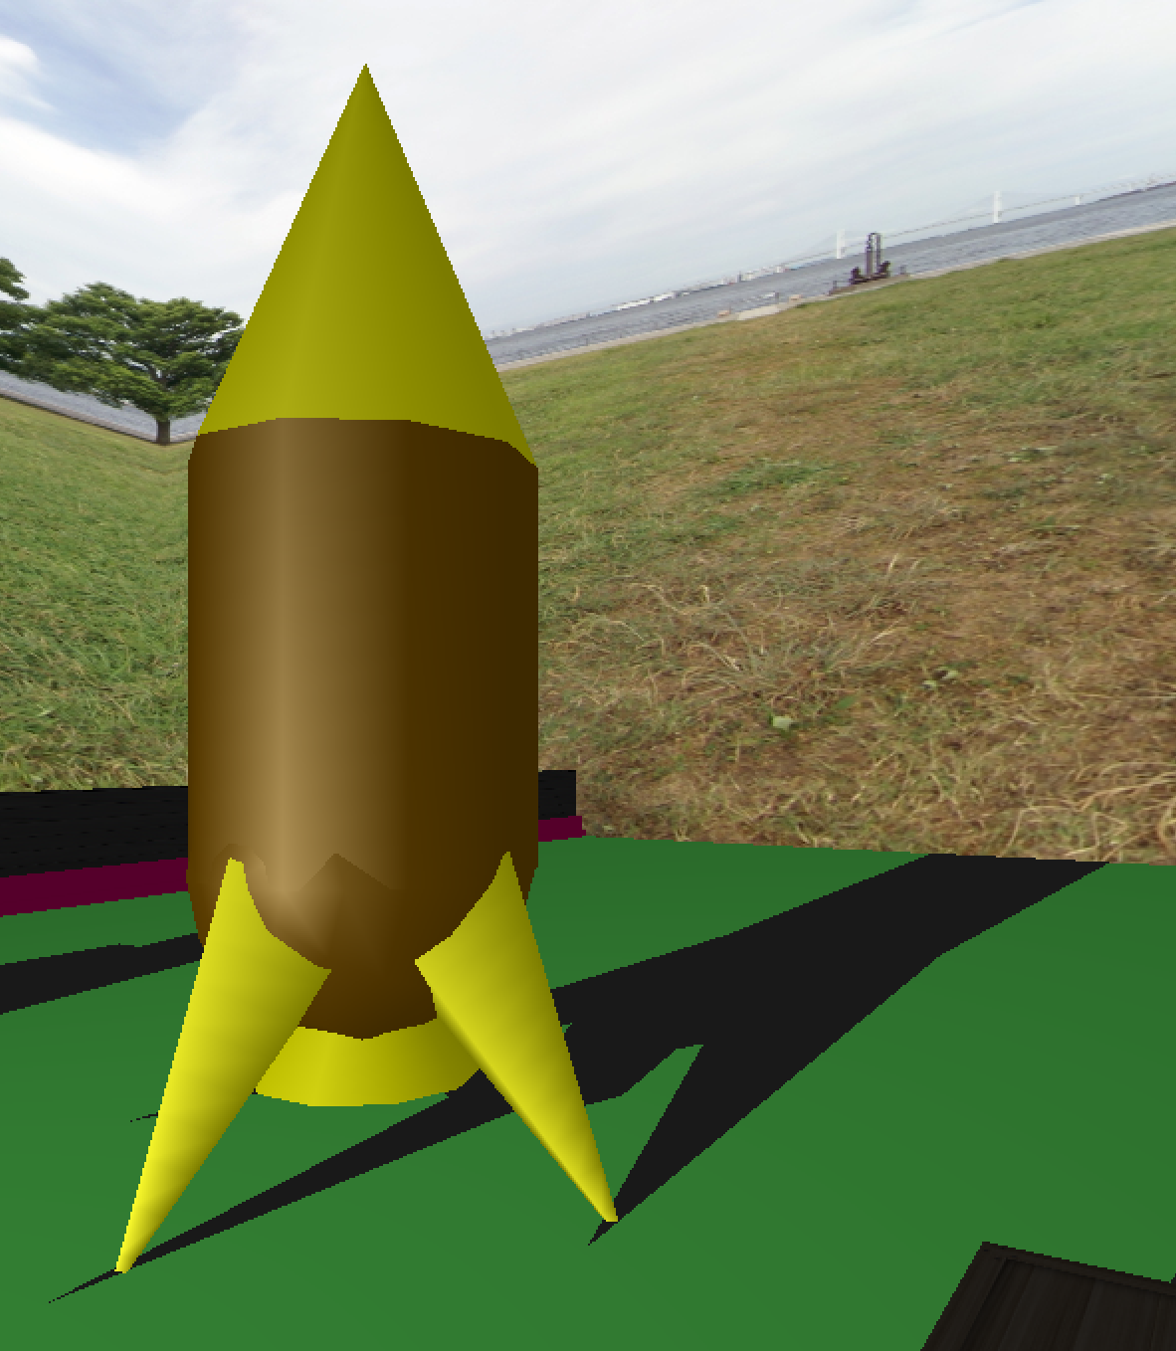

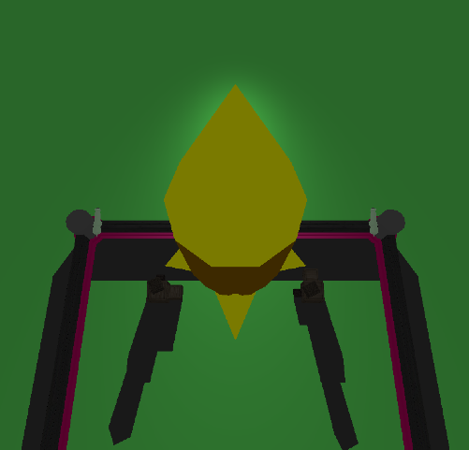Example of spaceship taking off  
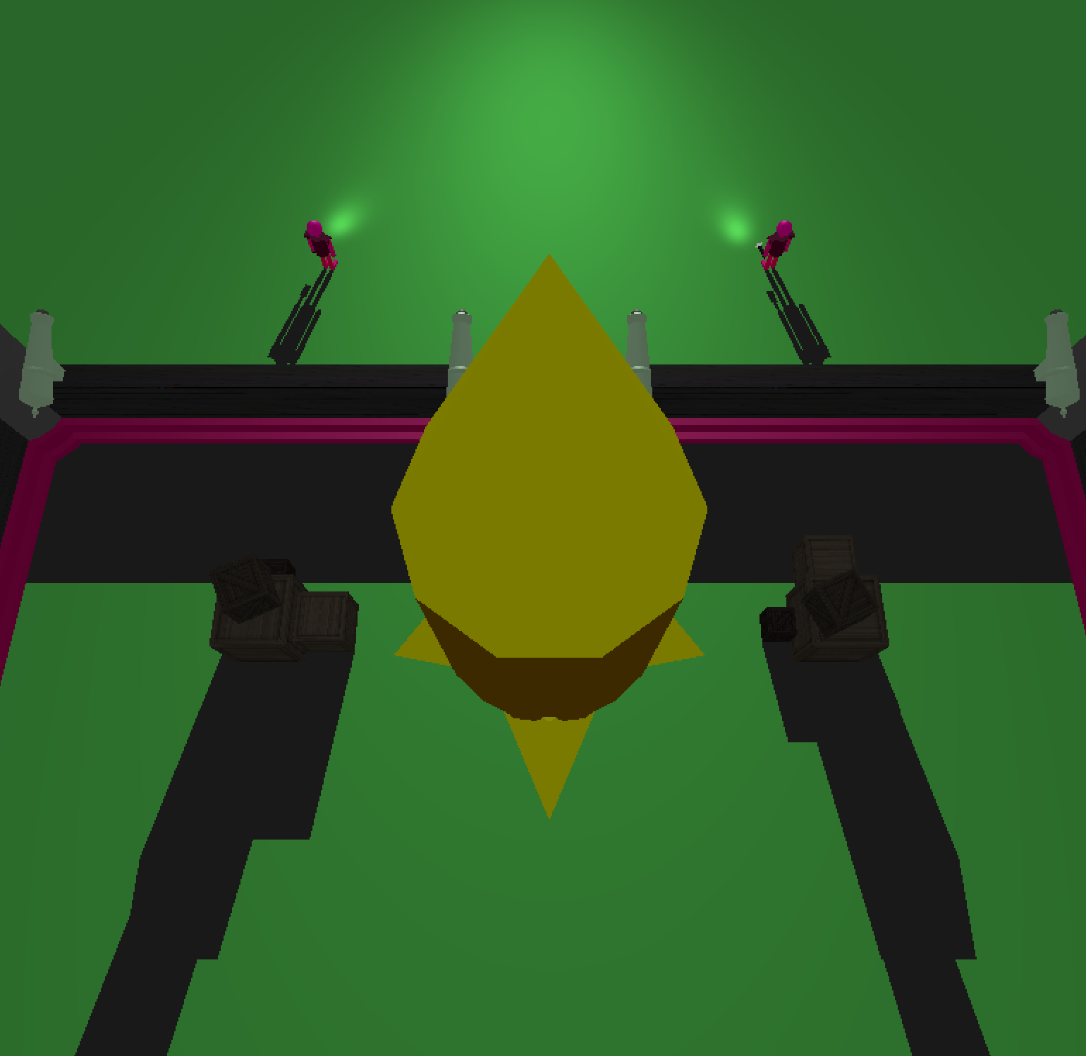

**External Resources:**  
Used textures provided from these sites under an open source license:  
<http://www.humus.name/index.php?page=Textures>  
<http://www.humus.name/Textures/Yokohama3.zip>  
<https://opengameart.org/content/3-crate-textures-w-bump-normal>